Nutritional Therapy Interview Form

Name ________________________________________________________________________

Address ______________________________________________________________________

Telephone number ______________________ Email __________________________________

Occupation ___________________________ Date of birth ____________________________

Family situation ________________________________________________________________

What do you want from this session? _________________________________________________________

_____________________________________________________________________________________________

_____________________________________________________________________________________________

Present Health _____________________________________________________________

_____________________________________________________________________________________________

_____________________________________________________________________________________________

_____________________________________________________________________________________________

_____________________________________________________________________________________________

_____________________________________________________________________________________________

_____________________________________________________________________________________________

_____________________________________________________________________________________________

_____________________________________________________________________________________________

_____________________________________________________________________________________________

_____________________________________________________________________________________________

_____________________________________________________________________________________________

_____________________________________________________________________________________________

_____________________________________________________________________________________________

_____________________________________________________________________________________________

_____________________________________________________________________________________________

_____________________________________________________________________________________________

_____________________________________________________________________________________________

_____________________________________________________________________________________________

_____________________________________________________________________________________________
Past Health (illnesses, operations or accidents) __________________________________

_____________________________________________________________________________________________

_____________________________________________________________________________________________

_____________________________________________________________________________________________

_____________________________________________________________________________________________

_____________________________________________________________________________________________

_____________________________________________________________________________________________

_____________________________________________________________________________________________

Menstruation and menstrual cycle __________________________________________________

_____________________________________________________________________________________________

_____________________________________________________________________________________________

_____________________________________________________________________________________________

Medications and supplements _____________________________________________________

_____________________________________________________________________________________________

Bowel movements ______________________________________________________________

Other therapies being used _______________________________________________________

Life history, what’s happening emotionally __________________________________

_____________________________________________________________________________________________

_____________________________________________________________________________________________

_____________________________________________________________________________________________

_____________________________________________________________________________________________

_____________________________________________________________________________________________

_____________________________________________________________________________________________

_____________________________________________________________________________________________

_____________________________________________________________________________________________

_____________________________________________________________________________________________

_____________________________________________________________________________________________

_____________________________________________________________________________________________
Dietary Style (meat-eater, vegetarian, vegan, raw, macrobiotic etc.)

_____________________________________________________________________________

_____________________________________________________________________________________________

_____________________________________________________________________________________________

Main foods eaten: Breakfast ______________________________________________________

_____________________________________________________________________________

_____________________________________________________________________________________________

Lunch ________________________________________________________________________

_____________________________________________________________________________

_____________________________________________________________________________________________

Supper _______________________________________________________________________

_____________________________________________________________________________

_____________________________________________________________________________________________

Desserts _____________________________________________________________________

_____________________________________________________________________________________________

Snacks _______________________________________________________________________

_____________________________________________________________________________________________

Drinks _______________________________________________________________________

_____________________________________________________________________________

Cravings _____________________________________________________________________

_____________________________________________________________________________________________

Favourite taste _________________________________________________________________

Other foods eaten or not eaten ____________________________________________________

_____________________________________________________________________________________________

_____________________________________________________________________________________________

_____________________________________________________________________________________________

_____________________________________________________________________________________________

Diagnosis

Yin/yang constitution ____________________________________________________________

Yin, yang, yin & yang condition ____________________________________________________

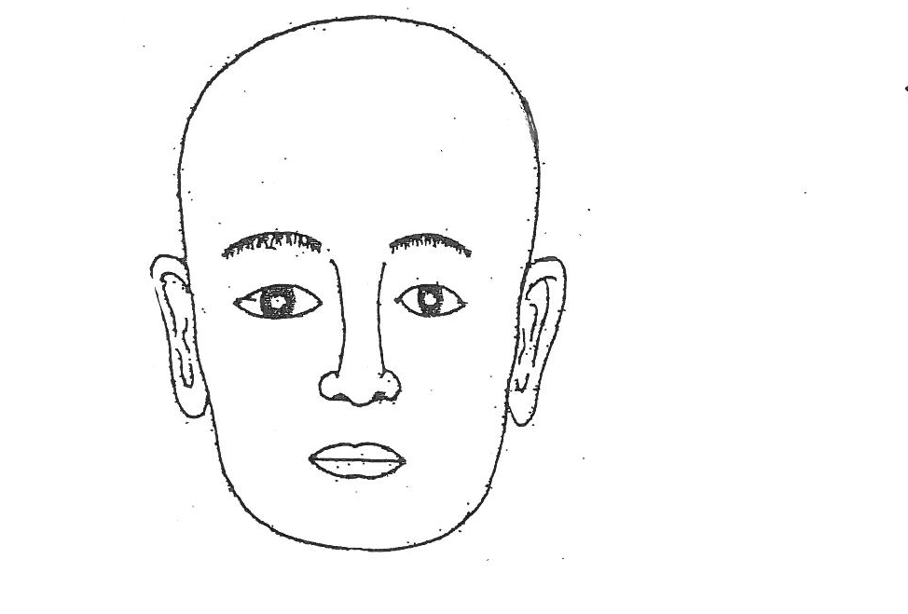
Facial diagnosis

Skin colour _________________

Main imbalances showing in face __________________________________________________

_____________________________________________________________________________________________
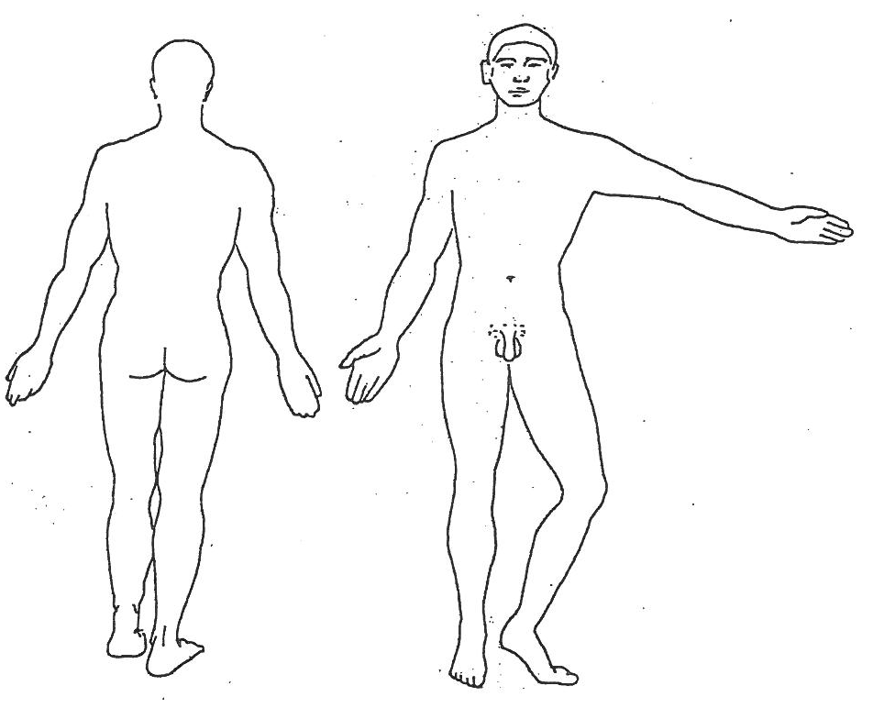

Sclera
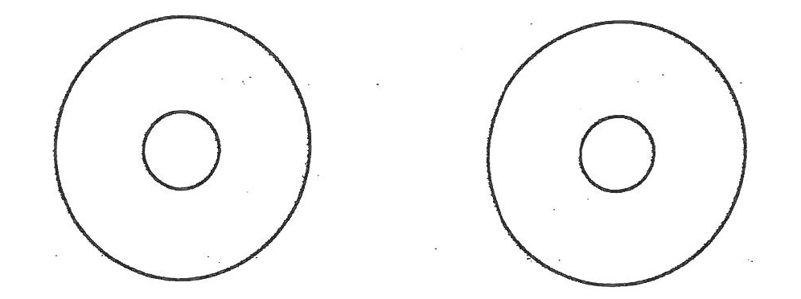

Back Areas Abdominal Palpation
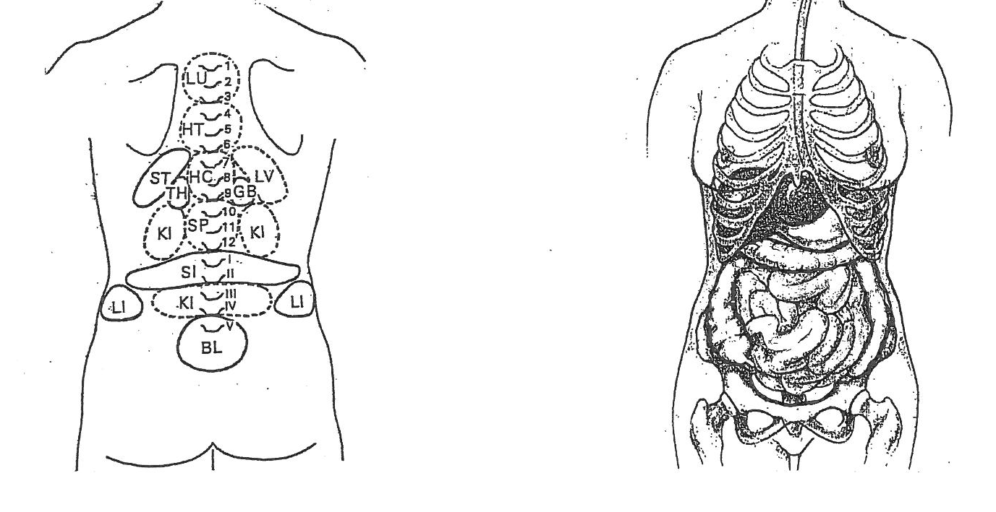
Hands & Feet
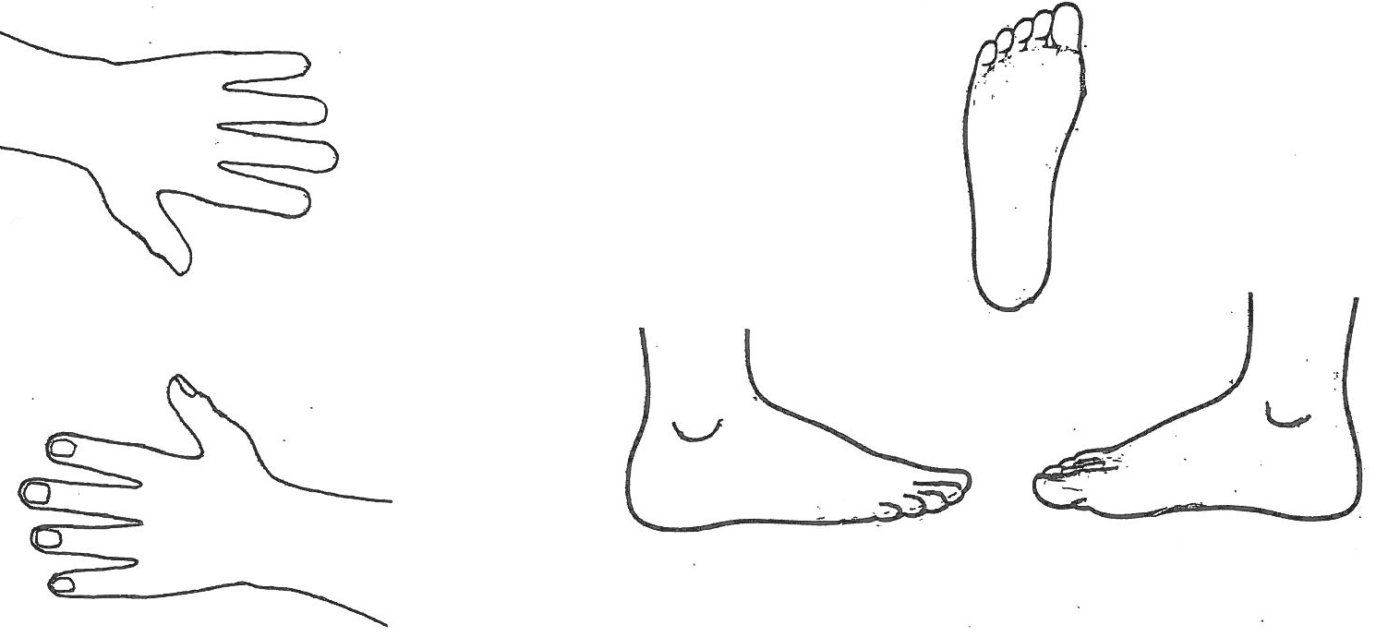
Five Transformations

Favourite or worst:

Season ___________________________________

Time of day ________________________________

Weather ___________________________________

Colour ____________________________________

Main Five Transformation imbalance ________________________________________________

Other Five Transformation imbalances ______________________________________________

_____________________________________________________________________________________________

Summary of your Oriental Diagnosis

_____________________________________________________________________________________________

_____________________________________________________________________________________________

_____________________________________________________________________________________________

_____________________________________________________________________________________________

_____________________________________________________________________________________________

_____________________________________________________________________________________________

_____________________________________________________________________________________________

_____________________________________________________________________________________________

_____________________________________________________________________________________________

_____________________________________________________________________________________________

_____________________________________________________________________________________________

_____________________________________________________________________________________________

_____________________________________________________________________________________________

_____________________________________________________________________________________________

_____________________________________________________________________________________________

_____________________________________________________________________________________________

_____________________________________________________________________________________________

Summary of your Health Advice

What are your main aims, what imbalances are you most wanting to change?

_____________________________________________________________________________________________

_____________________________________________________________________________________________

_____________________________________________________________________________________________

_____________________________________________________________________________________________

Dietary – foods to reduce _______________________________________________________

_____________________________________________________________________________________________

_____________________________________________________________________________________________

_____________________________________________________________________________________________

Foods to eat more of _______________________________________________________________________

_____________________________________________________________________________________________

_____________________________________________________________________________________________

_____________________________________________________________________________________________

_____________________________________________________________________________________________

Breakfast __________________________________________________________________________________

_____________________________________________________________________________________________

_____________________________________________________________________________________________

Lunch _____________________________________________________________________________________

_____________________________________________________________________________________________

_____________________________________________________________________________________________

Supper _____________________________________________________________________________________

_____________________________________________________________________________________________

_____________________________________________________________________________________________

Snacks ______________________________________________________________________

_____________________________________________________________________________________________

Desserts _____________________________________________________________________

_____________________________________________________________________________________________

Drinks _______________________________________________________________________

Other food recommendations ___________________________________________________

_____________________________________________________________________________________________

_____________________________________________________________________________________________

Lifestyle changes _____________________________________________________________

_____________________________________________________________________________________________

_____________________________________________________________________________________________

_____________________________________________________________________________________________

_____________________________________________________________________________________________

Exercise _____________________________________________________________________

_____________________________________________________________________________________________

_____________________________________________________________________________________________

Emotionally __________________________________________________________________

_____________________________________________________________________________________________

_____________________________________________________________________________________________

_____________________________________________________________________________________________

_____________________________________________________________________________________________

_____________________________________________________________________________________________

_____________________________________________________________________________________________

_____________________________________________________________________________________________

Other ________________________________________________________________________

_____________________________________________________________________________________________

_____________________________________________________________________________________________

_____________________________________________________________________________________________

_____________________________________________________________________________________________

_____________________________________________________________________________________________

_____________________________________________________________________________________________

